# Needs to start moving both database simultaneously.
# Watch on database SIEBEL to prevent it move back if it not start properly on target server.

# 0. Open log window.
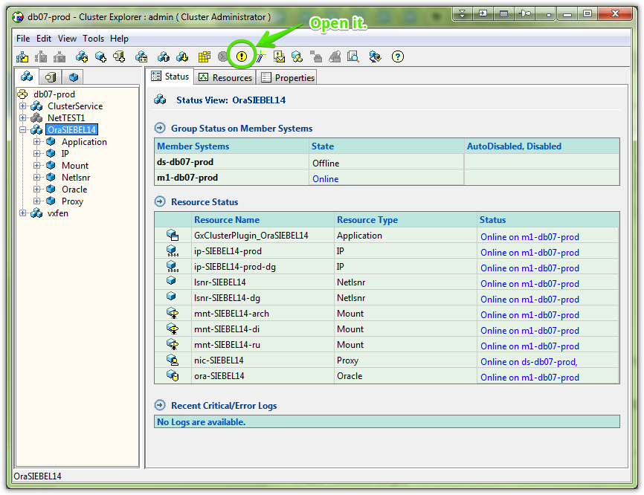
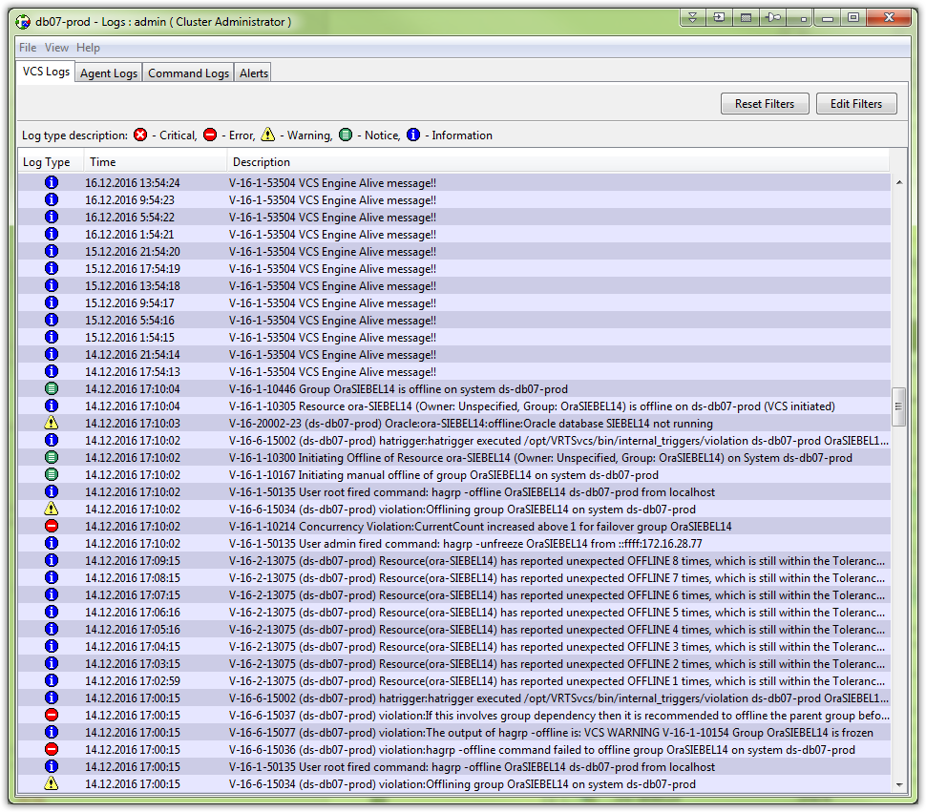

# 1. Start “Switch to” from context menu. Do it for PRIME4 and SIEBEL databases.
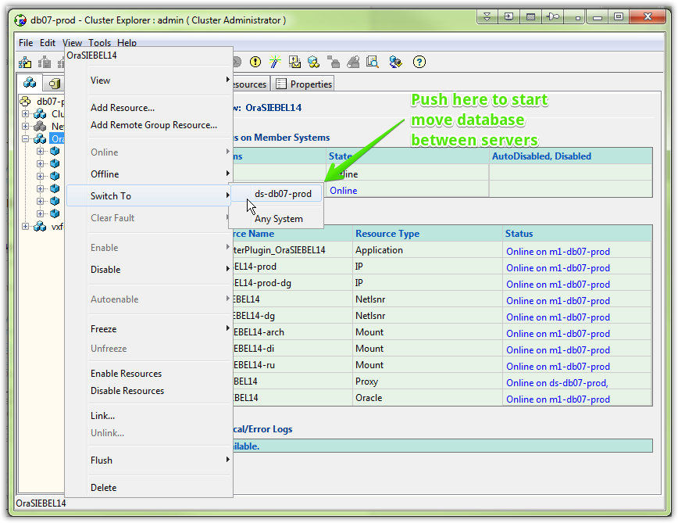

# 2. Watch turning off rectangles, and then do “Disable” option.
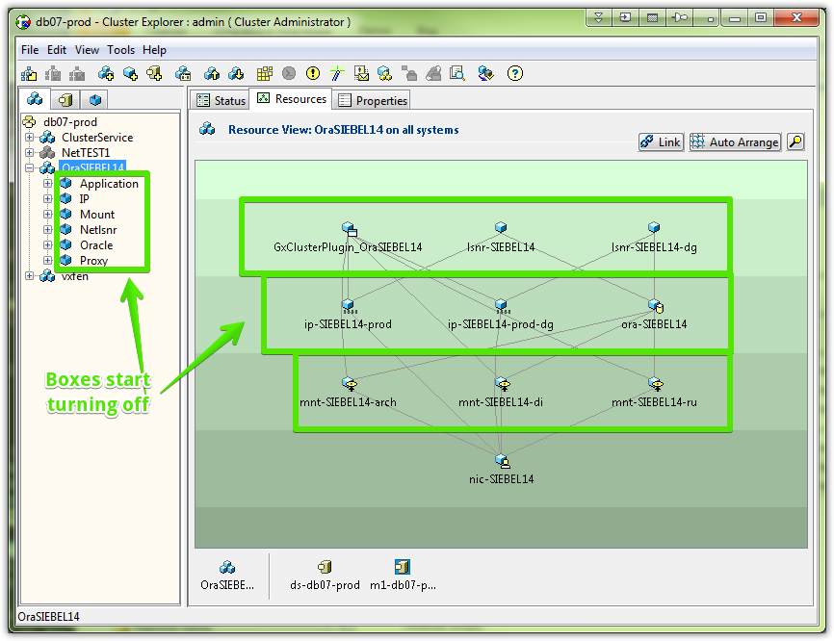
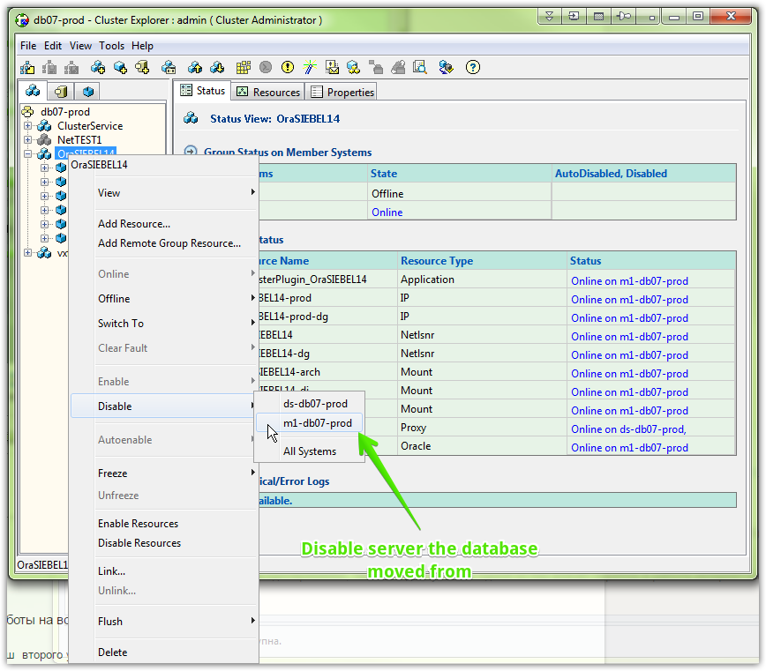

# 3. Then turn on disabled server if database start successfuly.

----
# Not all was going good.
# Database SIEBEL was not started on their new server in DS, successfully.

# I called to Aleksandrov.
# At the first time he had seen log messages and decided to mount three nfs resources by hand. Mounted it but nothing was changed.
# After that he tried to start oracle. To do that I clean faults via GUI.
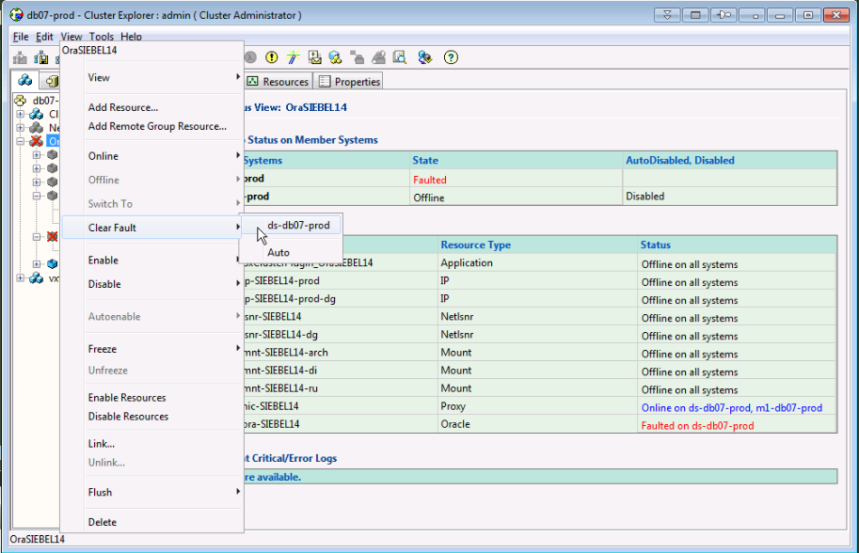

# Then became available to make database online. At this time had seen only one available server.
# Follow screenshot was made on test veritas cluster.
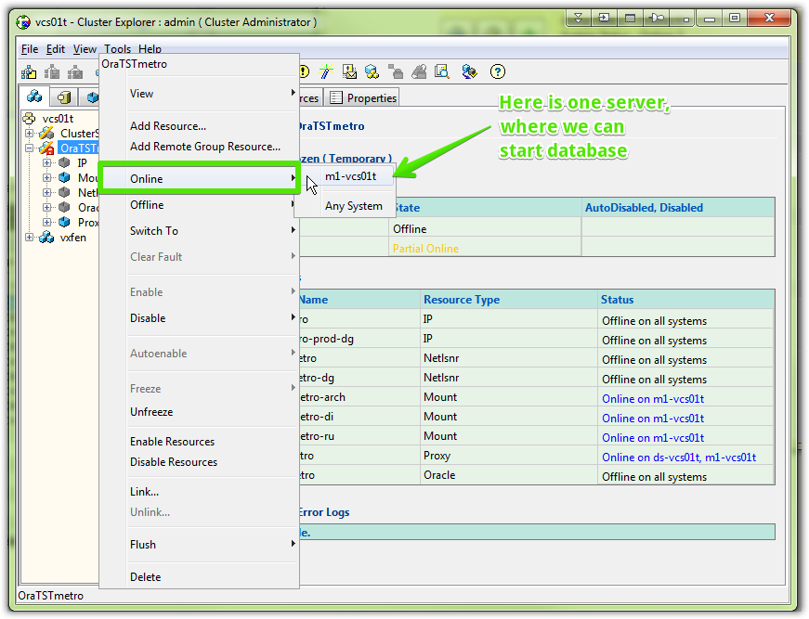

# This time start oracle was not successful again.
# Varakuta Sergey, that there was not enough amount of memory to start database.
# Varakuta changed appropriate parameters and we tried to start database again. Before it we waited when veritas finished its first attempt to start oracle. We saw into logs.

# At the second attempt oracle started work properly.

# After a while I removed offline state on server in M1, turned before at the begining of my works.

# One hour is shifted in this log. In real it was on one hour earlier, than we can see here.
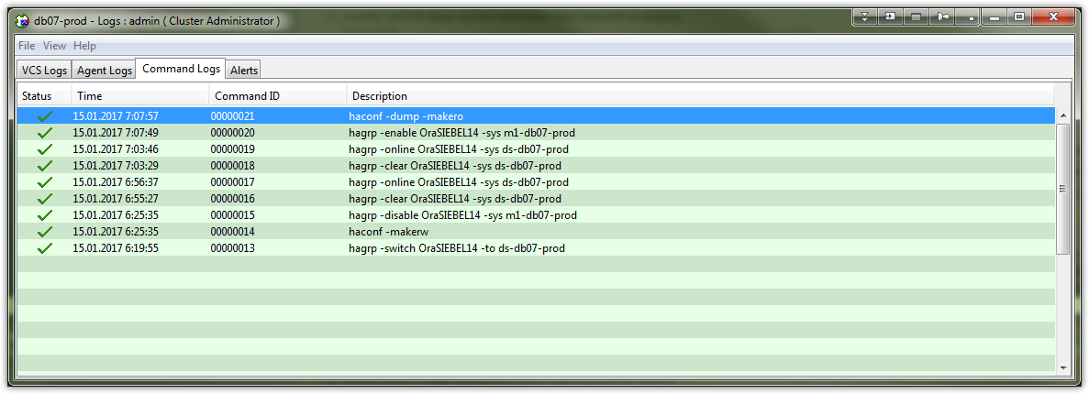

From: Varakuta Sergey
Sent: Thursday, January 12, 2017 3:20 PM
To: unix-admins <unix-admins@tinkoff.ru>
Cc: oradba <oradba@tinkoff.ru>
Subject: RE: Перезапуск баз PRIME4 и SIEBEL в ночь с субботы на воскресенье

SIEBEL надо перевезти на родную площадку в DS (+ включить кэш второго уровня – flash_cache)
PRIME4 надо перевезти в M1 чтобы поставить в сервер DS плату SSD (тоже для flash_cahe)

Кто будет от unix-admins ?

From: Varakuta Sergey
Sent: Thursday, January 12, 2017 3:06 PM
To: processing_all <processing_all@tinkoff.ru>; siebel-admins <siebel-admins@tinkoff.ru>; portal-adm <portal-adm@tinkoff.ru>
Cc: oradba <oradba@tinkoff.ru>; unix-admins <unix-admins@tinkoff.ru>
Subject: Перезапуск баз PRIME4 и SIEBEL в ночь с субботы на воскресенье

В ночь с субботы на воскресенье нужно перевести базы PRIME4 и SIEBEL на другие площадки (PRIME4 в M1, SIEBEL в DS)
Для этого необходимо выполнить перезапуск баз
Предлагаю выполнить эти работы в час ночи, чтобы за ночь успели разогреться кэши на базах.
Предлагаю выполнить эти работы одновременно, так как недоступность одной из баз влечёт перебои в работе интернет-банка.

С уважением,

Сергей Варакута
Руководитель отдела

db01-prod
----------------------------------------------------------------------------------------------
OraBB_DTA m1-db01-prod |ONLINE|
OraIDA m1-db01-prod |ONLINE|
OraLOYALTY m1-db01-prod |ONLINE|
OraPORTAL ds-db01-prod |ONLINE|
OraSSO m1-db01-prod |ONLINE|

db02-prod
----------------------------------------------------------------------------------------------
OraAML m1-db02-prod |ONLINE|
OraAVAYA m1-db02-prod |ONLINE|
OraBSS17 m1-db02-prod |ONLINE|
OraBUFF m1-db02-prod |ONLINE|
OraCREDB m1-db02-prod |ONLINE|
OraEMREP m1-db02-prod |ONLINE|
OraEVAM m1-db02-prod |ONLINE|
OraHRSPACE m1-db02-prod |ONLINE|
OraODS m1-db02-prod |ONLINE|
OraREPORTS m1-db02-prod |ONLINE|
OraRMCAT m1-db02-prod |ONLINE|
OraSASAUX ds-db02-prod |ONLINE|
OraSD m1-db02-prod |ONLINE|
OraWFM m1-db02-prod |ONLINE|
OraWOF m1-db02-prod |ONLINE|
OraXXI m1-db02-prod |ONLINE|
OraXXI_MFO m1-db02-prod |ONLINE|

db05-prod
----------------------------------------------------------------------------------------------
OraACS m1-db05-prod |ONLINE|
OraAG m1-db05-prod |ONLINE|
OraFG m1-db05-prod |ONLINE|
OraONL4ACQ m1-db05-prod |ONLINE|
OraOPS m1-db05-prod |ONLINE|
OraPG2 ds-db05-prod |ONLINE|
OraPRI4ACQ m1-db05-prod |ONLINE|

db06-prod
----------------------------------------------------------------------------------------------
OraBPM m1-db06-prod |ONLINE|
OraEDA m1-db06-prod |ONLINE|
OraESB m1-db06-prod |ONLINE|
OraESB_MSGS m1-db06-prod |ONLINE|
OraFILENET m1-db06-prod |ONLINE|
OraGRMAPM ALL |OFFLINE|
OraILOG_BPM m1-db06-prod |ONLINE|

db07-prod
----------------------------------------------------------------------------------------------
OraSIEBEL14 m1-db07-prod |ONLINE|

db08-prod
----------------------------------------------------------------------------------------------
OraACQ m1-db08-prod |ONLINE|
OraMFM m1-db08-prod |ONLINE|
OraONLINE4 m1-db08-prod |ONLINE|
OraPRIME4 ds-db08-prod |ONLINE|

